## 

AUGUST 2019

Patient Newsletter

alker

edical

roup

W

M

G

**CLOSING TIMES FOR TRAINING,**

**BANK HOLIDAYS**

**We will be closed on:**

**TUESDAY 10 SEPTEMBER - P.M. ONLY FOR TRAINING**

**WEDNESDAY 16 OCTOBER - P.M. ONLY FOR TRAINING**

**BANK HOLIDAY 26 AUGUST – ALL DAY**

**When we are closed and you need emergency help ring 999 and ask for an ambulance for other urgent medical help and advice call the 111 service**

**NEW STARTERS AND LEAVERS AT THE PRACTICE**

Since our last newsletter Dr. Karle has joined the GP team as partner. She replaces Dr Pearston who has retired. We wish Dr Karle a long and happy career with us and wish Dr Pearston well for the future.

We say goodbye to Dr Furniss who has completed her training with us and welcome two new registrars starting this month:

Dr. Susan Abott

Dr. Oday Al Younes

We also have two new receptionists, Nicola and Elaine, starting this month.

We also have a new staff member behind the scenes in Administration named Sharon who is replacing Agim who has left for pastures new.

**PATIENT PARTICIPATION GROUP MEETING**

Our next meeting is on Thursday 19 September at 10:30 a.m.at the surgery. If you would like to attend or are interested in being part of the group please inform the receptionists and they will pass your details on to the practice manager.



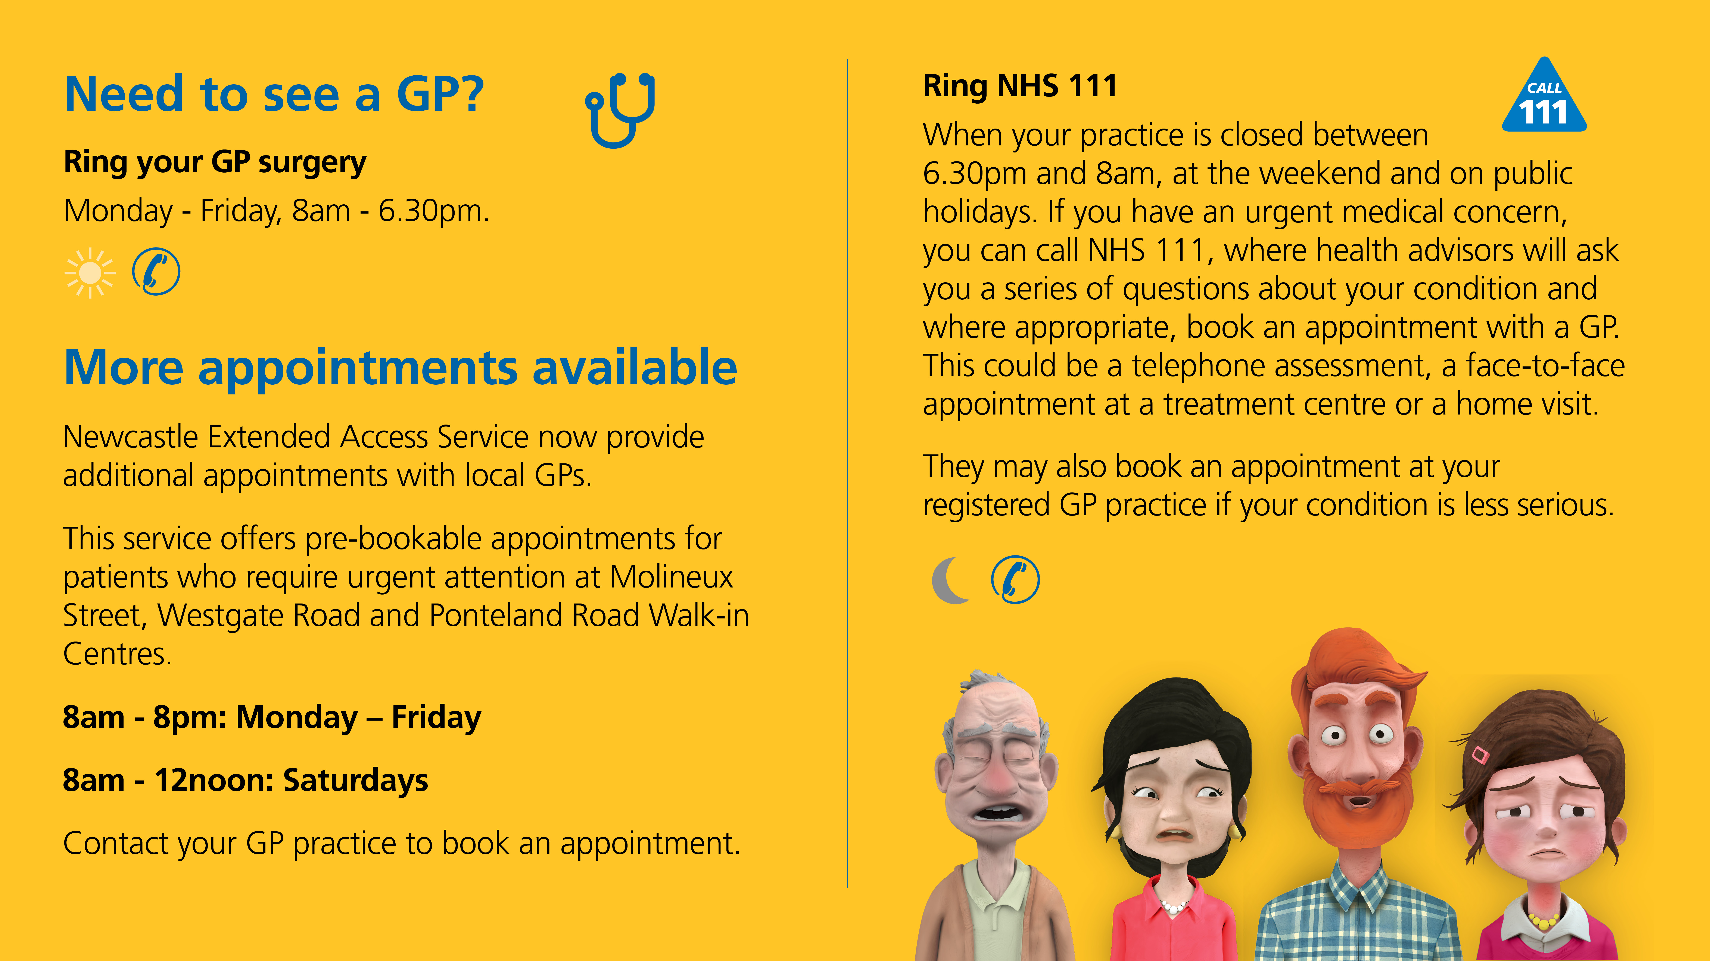

Two of our receptionists, Susan and Elizabeth have undergone training by the internationally known Annie Barr and are now fully fledged Phlebotomists. So the next time you need a blood test done it may well be one of these ladies who will see you.

If you have any suggestions for our Newsletter please write down on a piece of paper and pop into the suggestion box or send via the web site.