## 

December 2018

Patient *Newsletter*

alker

edical

roup

W

M

G

**CLOSING TIMES OVER CHRISTMAS**

We will be closed:

**Christmas Day**

**Boxing Day**

**New Year’s Day**

**When we are closed and you need emergency help ring 999 and ask for an ambulance for other urgent medical help and advice call the 111 service – see below**

Wishing all our patients a very Merry Christmas and a very happy New Year.



**NEW STAFF – PHYSICIAN’S ASSISTANT**

We have been involved in the development of Physician’s Assistants (PA) at Walker medical Group for the past couple of years, most of you will remember Maddie who was our first PA student. We have a new student with has just started with us, Kieran White, he will be here for a year on Tuesdays. He comes from a nursing background but has decided to develop into the role of a PA. He will be working with the whole team over his time here and getting some experience of General Practice.



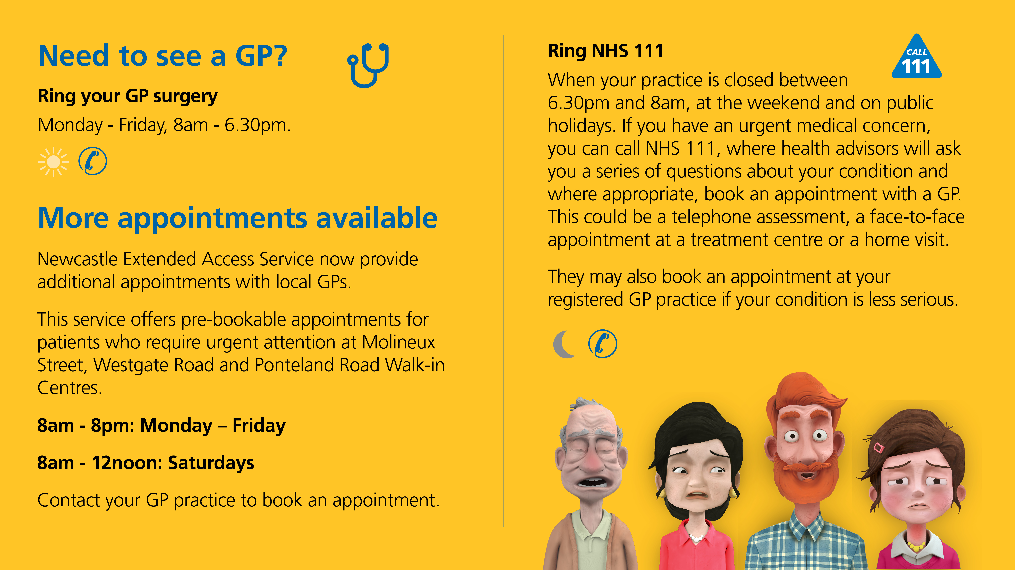

**CHANGE OF NURSING STAFF**

Sister Lewis, who has been with us since September 2013, is leaving at the beginning of January. Sister Lewis is an important member of the team and we wish her well in her new post. We welcome Sister Bell who is joining the team in January and will be working with us in a full time capacity.

If you have any suggestions for our Newsletter please write down on a piece of paper and pop into the suggestion box or send via the web site.