August 2018
Patient Newsletter

alker
edical
roup
W
M
G

NEW STAFF

We are happy to announce new members of our team.

Sister Elizabeth Potter joined us last month as a Career Start Nurse and Doctor Chera is a registrar who will be with us for six months. You may remember Dr Dunn, Registar. She is returning for a several weeks.

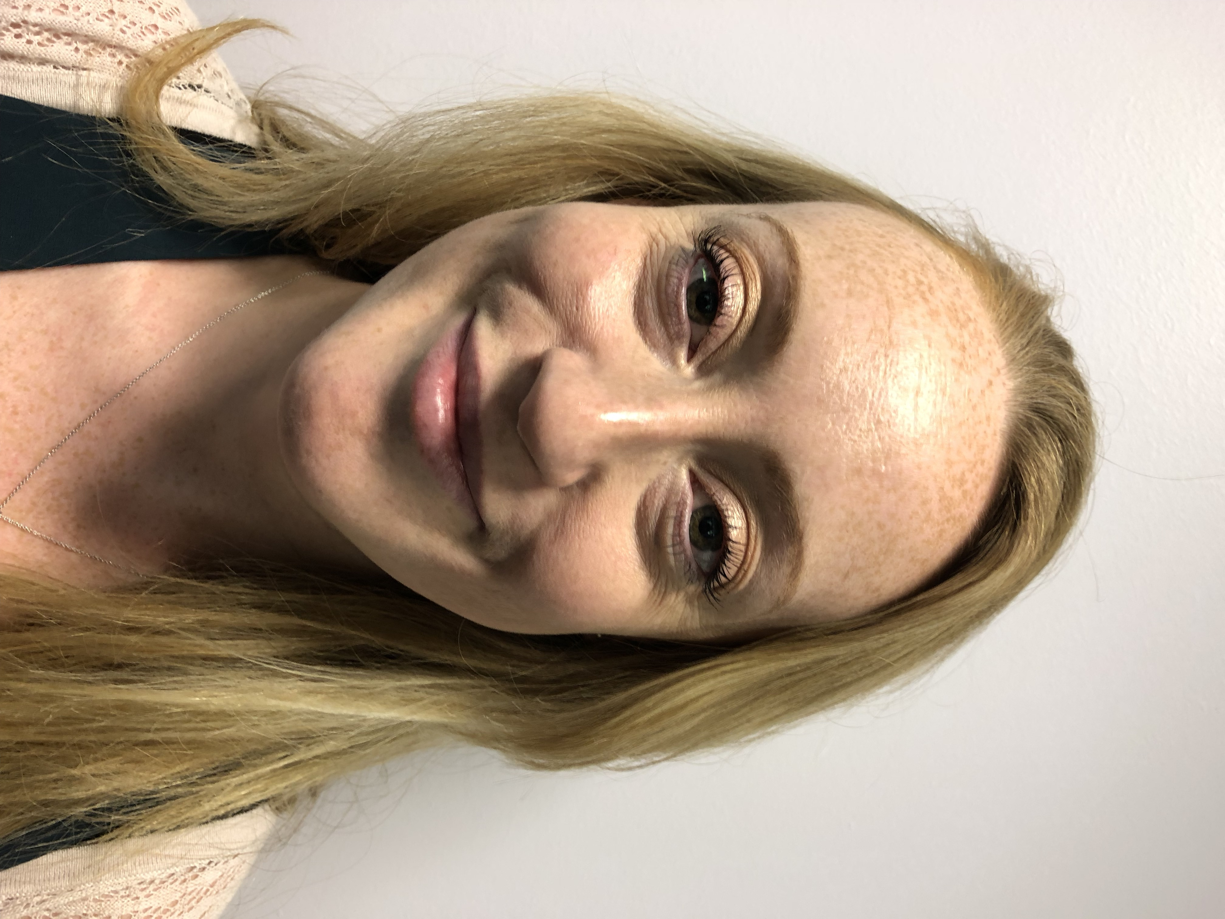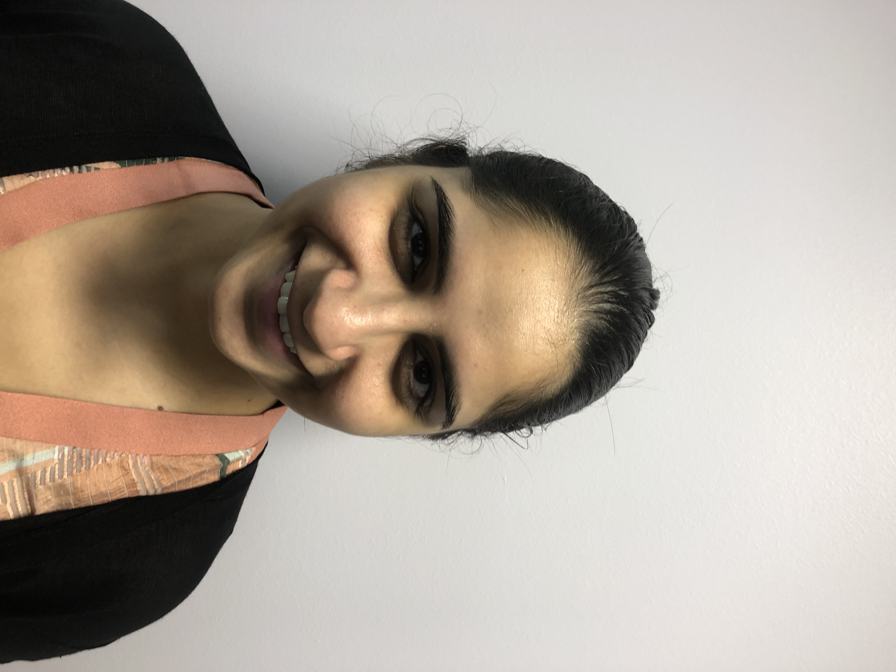
Sister Potter Dr Chera

SAME DAY HELP FOR YOUR POORLY CHILD

We offer same day access to a consultation for acutely unwell children and young people.
If your child has become unwell in the last few days and you would like urgent advice then ring the surgery and the receptionist will arrange for a doctor to speak to you. Then, if necessary, the doctor will arrange to see your child that day. This could save you an unnecessary trip to A+E or a Walk-in Centre.

THE NHS 70TH BIRTHDAY COFFEE MORNING

This was held at the practice and was a great success. Thank you for all those who participated. £56.29 was raised for the Alzheimer’s Society/

BE CAREFUL OF THE SUN!

It is not often we get such a warm summer. It can catch us out. Please make sure you do the following:

- Keep out of the sun between 11 a.m. and 3 p.m.
- If you have to go out in the heat, walk in the shade, apply sunscreen and wear a hat and light scarf.
- Avoid extreme physical exertion
- Wear light, loose-fitting cotton clothes.
- Have plenty of cold drinks and avoid excess alcohol, caffeine and hot drinks
- Eat cold foods, particularly salads and fruit with a high water content
- Take a cool shower, bath or body wash
- Sprinkle water over the skin or clothing, or keep a damp cloth on the back of your neck.

-------------------------------------------------------------------------
PATIENT PARTICIPATION GROUP MEETING
Our next meeting is on Tuesday 25 September at 10:30 a.m. at the surgery. If you would like to attend please inform the Practice Manager. If you cannot but are interested in being part of the group please complete, detach, and give to the receptionist.

I could complete surveys on line Yes No

I would prefer to attend Morning Afternoon

Name DOB

Home address

Telephone number

Email address
If you have any suggestions for our Newsletter please write down on a piece of paper and pop into the suggestion box or send via the web site.

